DOCKER WORKFLOW

DOCKER enforces a structured workflow that improves collaboration, traceability, and efficiency across teams.
This is primarily through 2 forms of revision control
- Filesystem layers
- Image Tags

Filesystem layers :
Docker containers are made up of stacked filesystem layers which are identified as a unique hash. Each new set of changes made during the build process is laid on top of previous changes.
When you do a new build you only have to rebuild the layers that follows the changes you’re deploying.
This saves a lot of time and bandwidth because the containers are shipped as layers and you dont have to ship the layer that the container has already stored.

DISCUSSION:
Question 1:
Why do you think Docker’s layered design reduces deployment risk compared to traditional packaging?
Answer : Since, dockered layered filesystem design only ships the container as a layered which has file changes in it , it doesnt have to ship the whole layered because they are already stacked in the server, this reduces human error.
Also, once the new layered is added or updated it is identified as a unique hash therefore, where each new changes made during the build process are laid on top of previous changes, with this process you can be quite sure about what the changes have happened.

Question 2:
If two Data Engineers are building similar images, how might Docker’s caching mechanism benefit CI/CD?
1. Faster Build : Docker build's image Layer-by-layer and each instruction in a docker-file creates a new layer. When the layer's content especially the preceding one doesn't change Docker cache the layers where its not changeing the content or changing the code, and reuses the cache layer instead of rebuilding it.
2. Consistency across Build : The cache mechanism ensures identical DockerFile instructions and therefore produces identical layers, leading to consistent build environments and reproducible images across different builds and engg.

3. Optimized Image size : By reusing cached layer, Docker avoid duplicating identical content within different images versions, contributing to smaller image sizes and faster image pulls and pushes within CI/CD
Example of 3 pts
if both the engineers are working on 2 different features build on the same image and same libraries. Docker will caches these common layers. when 2nd engineer builds their image, docker will leverage the cached layer from the first engineer's build significantly speeding the process. This benefit subsequent build within the same CI/CD pipeline

Data Engineering / MLOps Relevance
- In ML pipelines, layers can separate:
  - Base dependencies (Python, PyTorch)
  - Data processing libraries (Pandas, Spark)
  - Model code
- Rebuilding only the model layer after code updates → saves time.
- In CI/CD, cached layers = faster container rebuilds during retraining or ETL deployment.

IMAGE TAGS
This solves the answer to the question “WHAT IS THE LATEST VERSION OF THE PRODUCTIONIZED APPLICATION “
Docker provides image tagging at the deployment time.
You can leave multiple revision of your application in the server and just tag them at the time of the deployment / release.
Rule of thumb : Just dont tag latest tag in production

Smart Notes
- Tags act like version labels (e.g., v1.2, 2025-10-15, stable).
- Multiple image versions can exist on the same host → easy rollback.
- latest = floating tag → changes automatically → dangerous for production stability.
- Consistent tagging standard = shared understanding between Dev, Data, and Ops team

SCENARIO
Imagine you’re maintaining a Docker image for a PySpark ETL job.
- You add a new dependency to requirements.txt.
- You rebuild the image.
- Docker rebuilds only 1 layer — not all.
This phenomenon is due to Docker's efficient layer-based caching system, and it is the desired behavior for a well-structured Dockerfile. By strategically ordering the commands in your Dockerfile, you ensure that a change to a single, frequently-updated file like requirements.txt only invalidates the cache for the steps that depend on it, not the entire image.
How Docker layer caching works
- Instruction as a layer: Each instruction in a Dockerfile (e.g., FROM, RUN, COPY) creates a read-only layer in the image.
- Cache lookup: When building, Docker checks if a cached layer for each instruction already exists. If the command and context (like the contents of a copied file) are unchanged, Docker reuses the existing layer, which is very fast.
- Cache invalidation: As soon as Docker encounters a command that has changed, it invalidates the cache from that point forward. All subsequent instructions are re-executed and create new layers, even if they appear identical to the previous build.
The optimized Dockerfile structure for your PySpark job
To achieve this fast rebuild, your Dockerfile should be structured to place the most stable instructions first and the most frequently changing instructions last.
- Start with the base image: This layer is typically the most stable and is at the bottom of the cache stack.
FROM bitnami/spark:3.5.1

Copy and install requirements: This is the key optimization for your scenario. You copy only the requirements.txt file and install the dependencies before you copy the rest of your application code.
# Set the working directory
WORKDIR /opt/bitnami/spark

# Copy only the requirements.txt file to invalidate the cache only when dependencies change
COPY requirements.txt .

# Install Python dependencies
RUN pip install --no-cache-dir -r requirements.txt

Copy the application code: The application code for your ETL job is what changes most frequently. By copying it last, any code change will only trigger a rebuild of this final layer and not the time-consuming dependency installation step.
# Copy the rest of the application source code
COPY . .

Define the entrypoint: This typically doesn't change once configured.
CMD ["spark-submit", "my_etl_job.py"]

Putting it all together
With this structure, when you add a new dependency to requirements.txt and rebuild:
- The FROM and WORKDIR layers are reused from the cache.
- The COPY requirements.txt . instruction is different, so its cache is invalidated, and a new layer is created.
- The RUN pip install command then executes. Docker fetches the new dependency, and because the cache was busted, a new layer is generated for the installed dependencies.
- The subsequent COPY . . layer is also invalidated because it comes after a changed layer, but this is typically a fast operation.
This process results in a minimal, targeted rebuild, drastically speeding up your development loop.

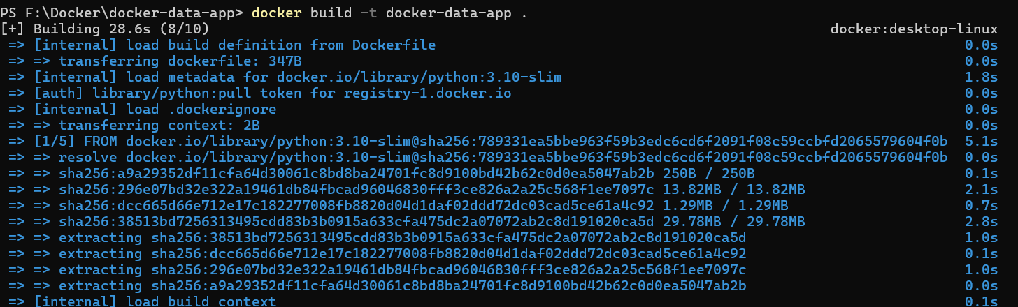
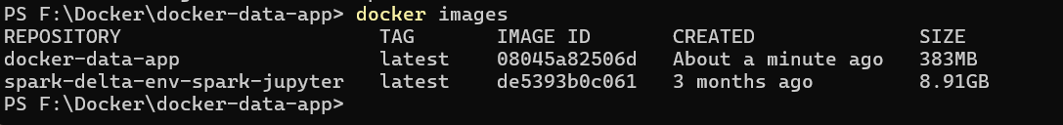
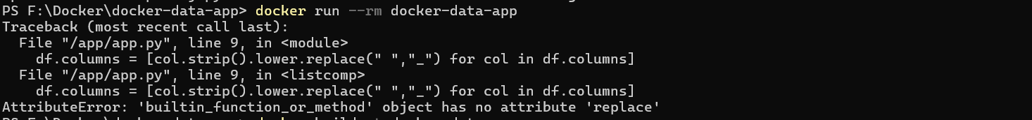
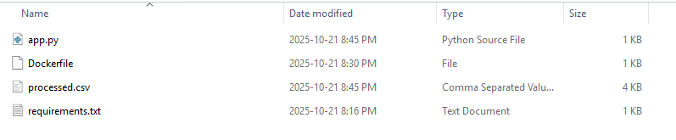

Mini Project 2 (Alt): Dockerize a Hugging Face NLP App
Build a containerized Python app that
Goal:
- Loads a pre-trained model from Hugging Face (e.g.,distilbert-base-uncased)
- Performs sentiment analysis or text classification on sample text
- Outputs predictions
Note this Project works around “distilbert-base-uncased” to do sentimental analysis and then we will compare the output with another pre-trained hugging face model “distilbert-base-uncased-finetuned-sst-2-english”
Suggested Project Structure:
hf-nlp-app/
│
├── app/
│ ├── predict.py # runs sentiment classification
│ └── sample_texts.txt # input texts
│
├── requirements.txt # Hugging Face + dependencies
├── Dockerfile

Create the above folders in your local and then save the following files
In the app folder, we have sample_texts.txt file
“
I love learning Docker and NLP!
This is the worst service ever.
Not bad, could be better.
Absolutely fantastic experience.
”
In Predict.py

from transformers import pipeline

# Load from local model + tokenizer
classifier = pipeline("sentiment-analysis", model="./models/distilbert-base-uncased", tokenizer="./models/distilbert-base-uncased")

# Read input file
with open("sample_texts.txt", "r") as f:
texts = [line.strip() for line in f if line.strip()] # Clean lines

# Run inference
results = classifier(texts)

# Print results
for text, result in zip(texts, results):
print(f"Text: {text}")
print(f"Label: {result['label']}, Score: {result['score']:.4f}")
print("-" * 40)

Dockerfile
FROM python:3.10-slim

WORKDIR /app

# Install dependencies
COPY requirements.txt .
RUN pip install --upgrade pip && \
pip install --no-cache-dir -r requirements.txt

# Download and cache the model during build
RUN python -c "from transformers import snapshot_download; snapshot_download('distilbert-base-uncased', local_dir='./models/distilbert-base-uncased')"

# Copy the rest of your code
COPY . .

# Run the app
CMD ["python", "app.py"]

This dockerfile while building the image such as
Docker build -t <file folder name> here in the case its hf-nl-app. This will throw an error
ImportError: cannot import name 'snapshot_download' from 'transformers' (/usr/local/lib/python3.10/site-packages/transformers/__init__.py)
That means the version of transformers you're installing (v4.40.1 from your requirements.txt) does not support snapshot_download.
To fix this we will use hf_hub_download instead
We will replace this line
RUN python -c "from transformers import snapshot_download; snapshot_download('distilbert-base-uncased', local_dir='./models/distilbert-base-uncased')"
To
RUN python -c "from hf_hub_download import snapshot_download; snapshot_download('distilbert-base-uncased', local_dir='./models/distilbert-base-uncased')"

AND ADD THIS TO requirements.txt
“
transformers==4.40.1
torch==2.3.0
huggingface_hub==0.23.0
”
Once this folders and file are saved. Open the terminal and run the docker commands
- Building the docker image
docker build -t hf-nlp-app
- Running the container to get the results
docker run --rm hf-nlp-app

After running the container you’ll notice the output that
This looks off for 3 reasons:
- All predictions are LABEL_1 — even for negative/neutral inputs.
- Score is ~0.5 — meaning the model is not confident.
- Lines are grouped into a single list, not individually evaluated.

Root Cause
You're using a base model (distilbert-base-uncased) which is not trained for classification (e.g., sentiment analysis). That’s why:
- It's missing classification layer weights (classifier.weight, etc.).
- It outputs untrained/default results.
To fix this we will use model
distilbert-base-uncased-finetuned-sst-2-english
update Your Dockerfile (line where we used snapshot_download):
RUN python -c "from transformers import snapshot_download; snapshot_download('distilbert-base-uncased-finetuned-sst-2-english', local_dir='./models/distilbert-base-uncased-finetuned-sst-2-english')"

Update Predict.py file

# Load from local model + tokenizer
classifier = pipeline("sentiment-analysis", model="./models/distilbert-base-uncased-finetuned-sst-2-english",
tokenizer="./models/distilbert-base-uncased-finetuned-sst-2-english")

Re-run the image build , you’ll notice that the building the image was quick and then rerun the container
The predict score will also increase.

The Two Hugging Face Models You Used
Model Name | Purpose | Pretraining | Fine-Tuned?
1. distilbert-base-uncased | General-purpose language understanding | Yes (masked language modeling) | ❌ No
2. Distilbert-base-uncased-finetuned-sst-2-english | Sentiment classification | Yes (masked LM) | ✅ Yes, on SST-2 dataset
Distilbert-base-uncased

➤ What is it?
A smaller, faster, cheaper version of BERT, trained by HuggingFace using knowledge distillation.

➤ Theory:
- Based on BERT, but 40% smaller and 60% faster with 97% performance.
- Trained using Masked Language Modeling (MLM) — predicts masked words in a sentence to learn grammar, semantics, and context.
For example:
"I love [MASK] learning!" → Model predicts "deep"

➤ Limitations:
- Not fine-tuned for downstream tasks (like sentiment, QA, etc.)
- Only good for extracting embeddings, not classification out of the box.

➤ Use cases:
- Text feature extraction
- Embedding generation
- Further fine-tuning on custom tasks

Why you used it:
You tested loading a raw model — this is like bringing in a car engine with no wheels. It starts but doesn’t go anywhere meaningful until you attach task-specific layers.

2. distilbert-base-uncased-finetuned-sst-2-english

➤ What is it?
A task-specific version of the same DistilBERT, fine-tuned for sentiment classification on the SST-2 dataset.

➤Theory:
- SST-2 (Stanford Sentiment Treebank v2) is a benchmark dataset for binary sentiment classification (positive or negative).
- The model uses the pre-trained DistilBERT base and adds a classifier head on top (a linear layer).
- It is then fine-tuned using thousands of labeled examples:
  - “I hate this movie” → Negative
  - “Best experience ever” → Positive

